**LAPORAN HASIL PRAKTIKUM**

**PEMBANGUNAN PERANGKAT LUNAK**

**INTRODUCTION TO GIT**



**Disusun Oleh:**

Arum Tiyas Handayani 082011633012

**PROGRAM STUDI S-1 SISTEM INFORMASI**

**FAKULTAS SAINS DAN TEKNOLOGI**

**UNIVERSITAS AIRLANGGA**

**2023**

1. **Install Git**

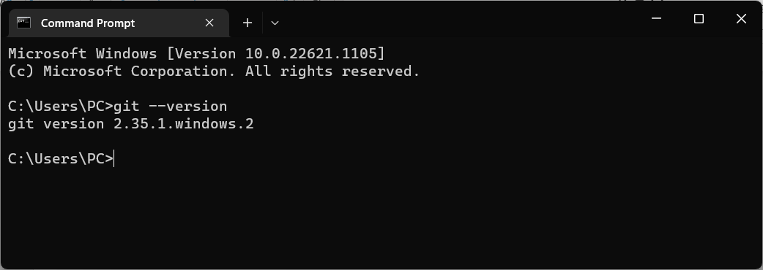

Keterangan: Telah melakukan instalasi Git yang dapat dibuktikan dengan cek versi melalui perintah “git –version”.

1. **Getting started with Git and GitHub**
   1. **Step 1: Sign up and installation!**

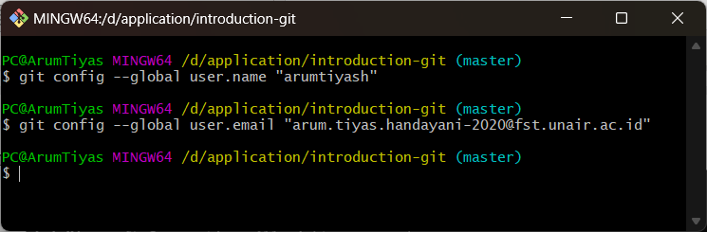

* 1. **I’m already comfortable with the terminal (Option 1)**

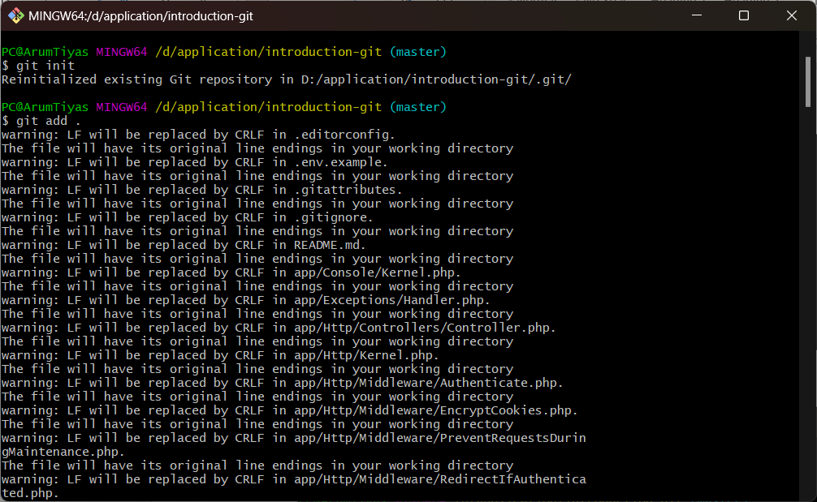

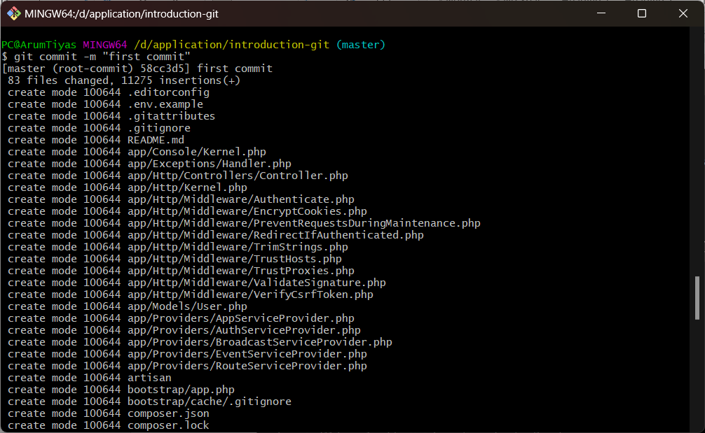

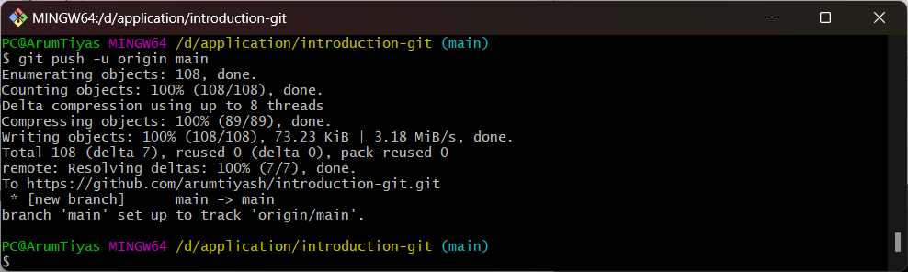

* 1. **I don’t know what you just said (Option 2)**

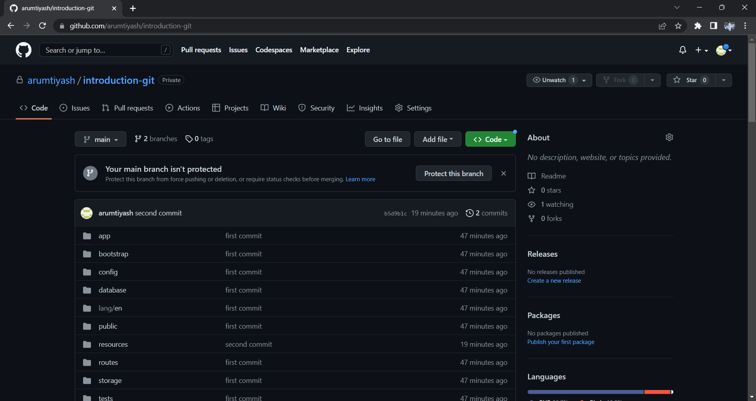

* 1. **Gimmie that project!**

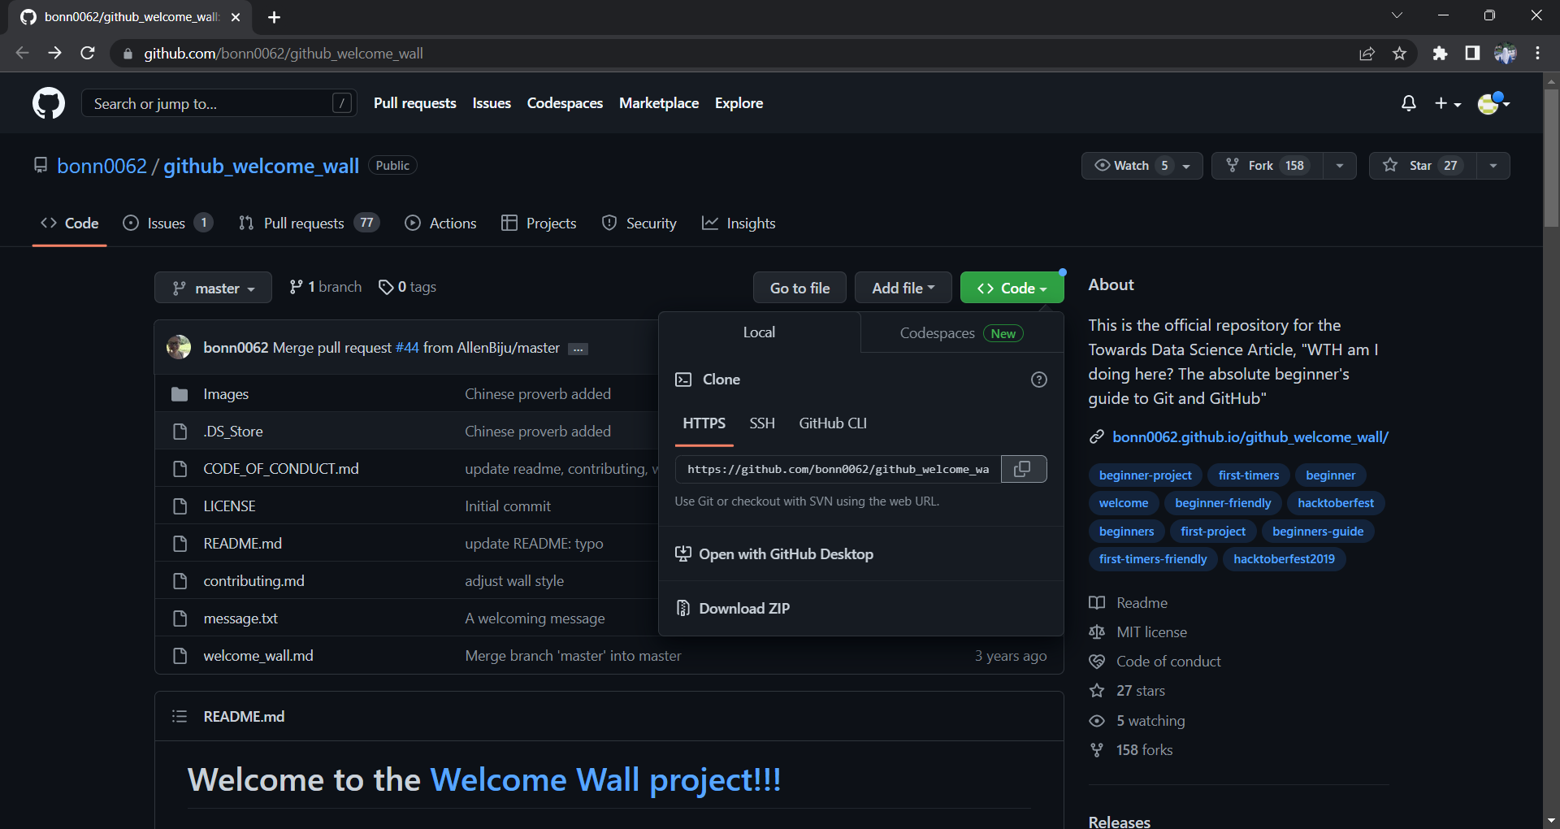

* 1. **Now it’s time to add some files to your project!**

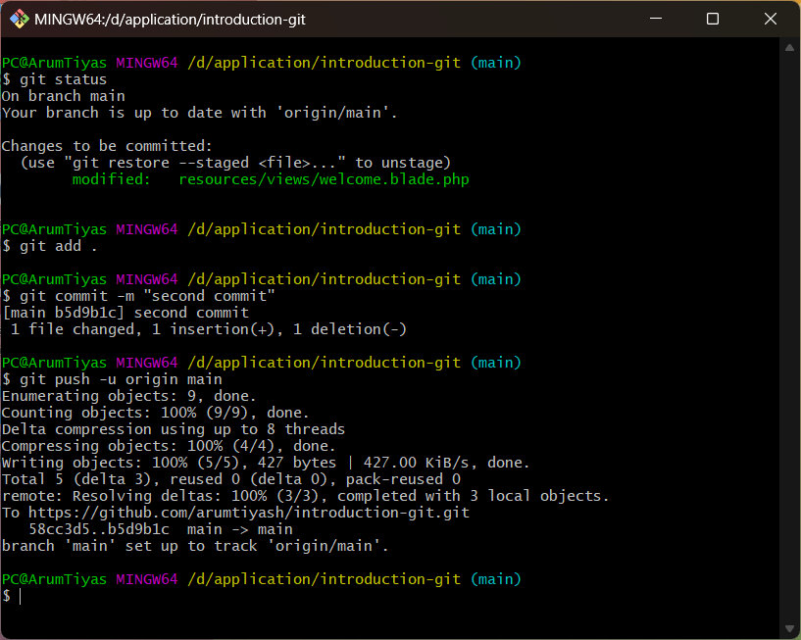

* 1. **GitHub flow**

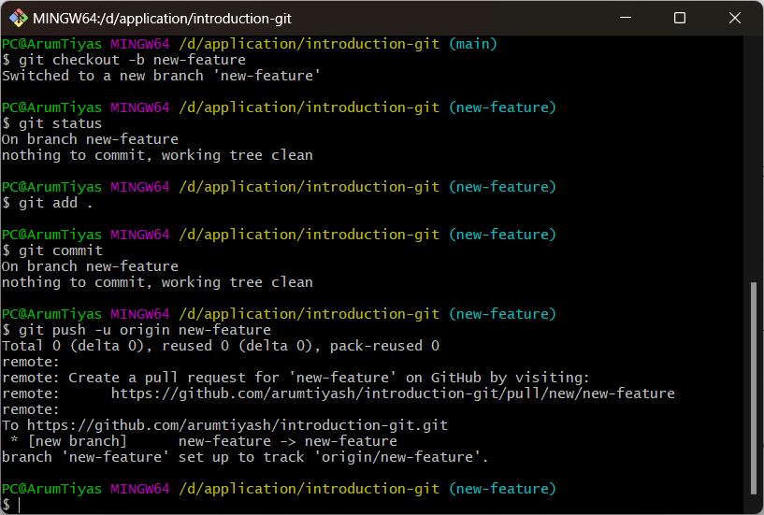

* 1. **Ummmmm…what? Can I do that on the website?**

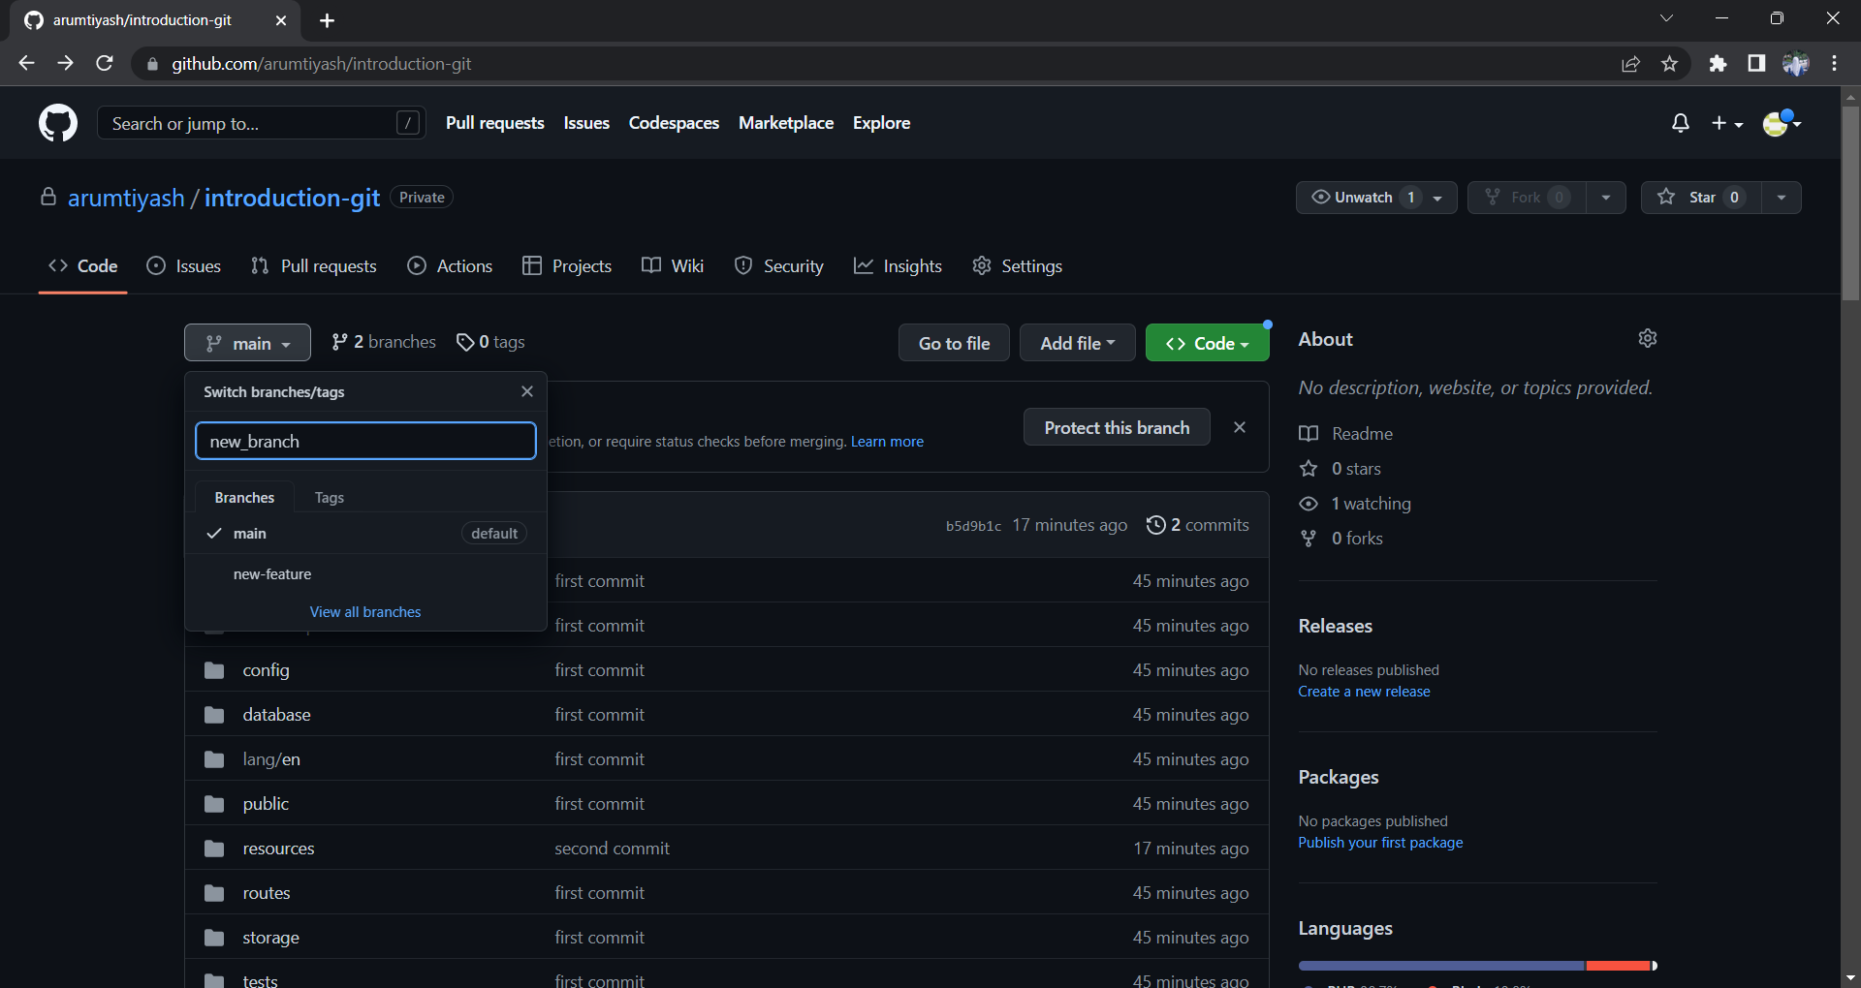

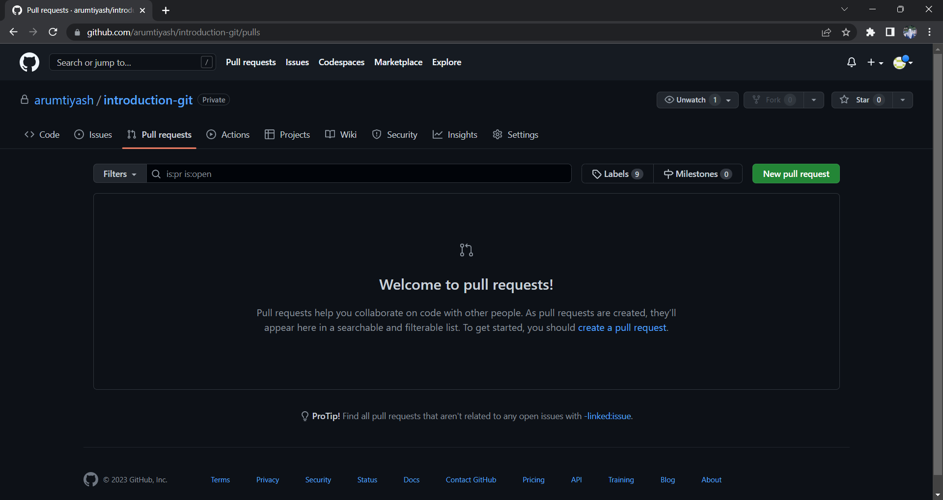

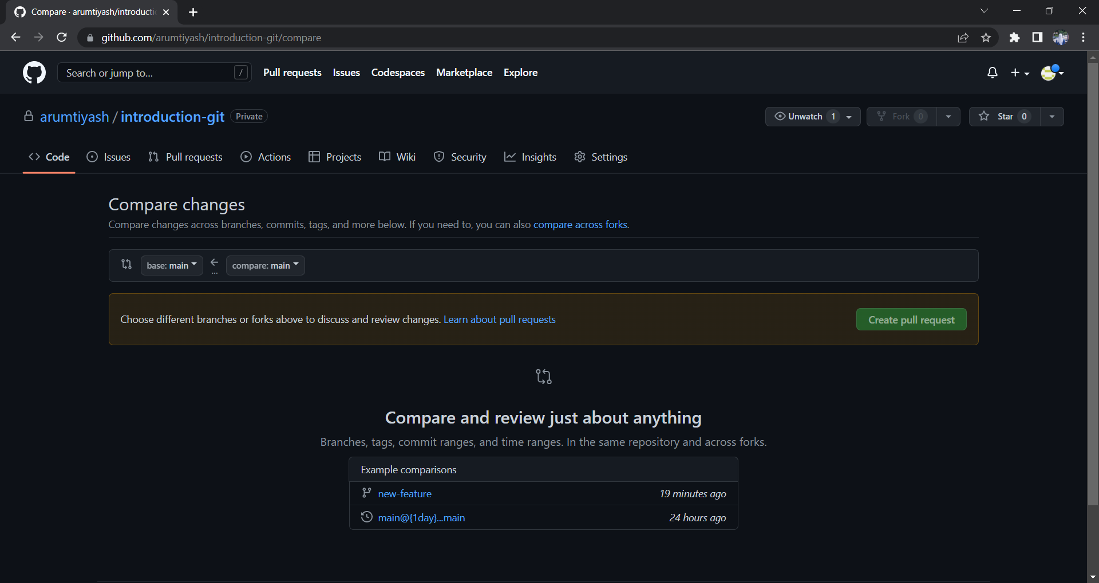

* 1. **Update and merge**

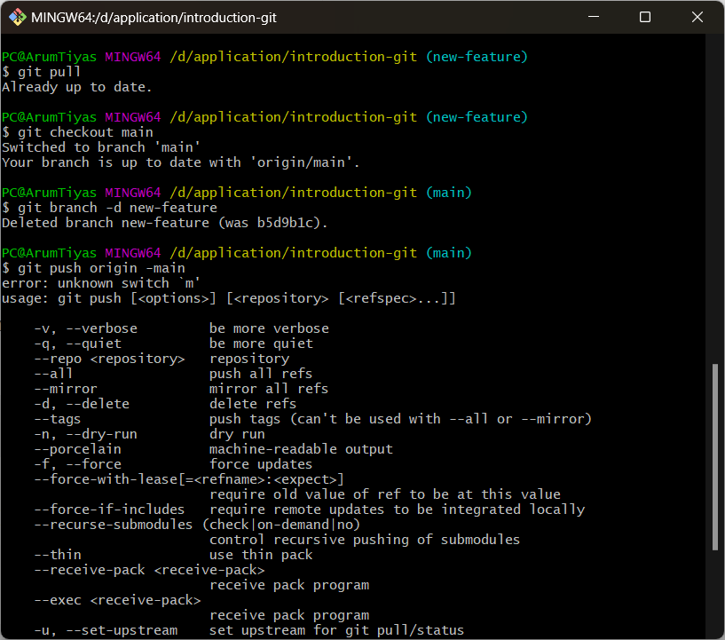

* 1. **Other helpful commands**

